DOS & DONTS
PRE-PLE 2025
HOT SET 3
SCIENCE
Time Allowed: 2 hours 15 minutes
Random No. |  |  |  |  |  | Personal No.
Candidate’s Name……………………………………………………………………….
Signature……………………………………………………………………………........
School Name: …………………………………………………..…………………………
Read the following instructions carefully:
- This paper has two sections: A and B.
FOR EXAMINERS’ USE ONLY
QN NO. | MARKS | EXR’S  NO.
1 - 10
11 - 20
21- 30
31 - 40
41 - 43
44 - 46
47 - 49
50 - 52
53 - 55
TOTAL
Section A has 40 questions
Section B has 15 questions

2. Answer all the questions. All the working for
both sections A and B must be shown in the
spaces provided.

3. All the working must be done using a blue or
black ball point pen or ink. Any work done in
Pencil other than graphs and diagrams will
Not be marked.

4. No calculators are allowed in the examination
Room.

5. Unnecessary changes in your work
and handwriting that cannot be read easily may lead to loss of marks.

6. Do not fill anything in the table indicated
“FOR EXAMINERS’ USE ONLY” and in the
boxes inside the question paper.

SECTION A: 40 MARKS
1. Name the type of teeth that first appears in baby’s mouth.
……………………………………………………………………………………………………........
2. Mention any one biological change that occurs in plants only.
……………………………………………………………………………………………………........
3. Why does a millipede coil when touched?
……………………………………………………………………………………………………........
4. State any one cause of truancy.
……………………………………………………………………………………………………........
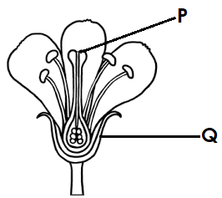
The diagram below show a structure of a flower. Study and use it answer questions 5 and 6.

5. Name part marked P.
……………………………………………………………………………………………………........
6. State the function of part marked with letter Q apart from protecting the flower at the same bud stage.
……………………………………………………………………………………………………........

7. Give any one advantage of a traditional beehive.
……………………………………………………………………………………………………........
8. In which one way does smoking affect the respiratory system?
……………………………………………………………………………………………………........
9. Which form of energy is produced by dry cells when the circuit is completed?
……………………………………………………………………………………………………........
10. How does ironing of clothes help in controlling skin infections?
……………………………………………………………………………………………………........
11. Calculate the volume of a stone with a density of 4g/cc and a mass of 60g.

12. State the use of water tank (cistern) in the toilet.
……………………………………………………………………………………………………........
13. How are bones important to the circulatory system?
……………………………………………………………………………………………………........
14. In which one way is a nursery bed important in crop farming?
……………………………………………………………………………………………………........
15. State any one disadvantage of zero grazing in cattle keeping.
……………………………………………………………………………………………………........
16. What scientific term is given to a meal that contains all food values in their right amounts?
……………………………………………………………………………………………………........
17. Write any one disadvantage of using wood fuel as a source of energy.
……………………………………………………………………………………………………........
The diagram is a simple machine; use it to answer questions 18 and 19.
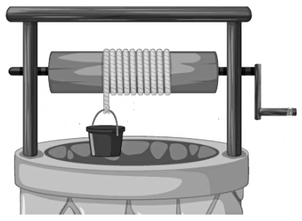
18. Identify the group simple machines represented by the diagram above.
……………………………………………………………………………………………………........
19. How useful is the above simple machine in the community?
……………………………………………………………………………………………………........
20. Give any one way of controlling bacterial diseases in human beings.
……………………………………………………………………………………………………........
21. How is the sebaceous gland useful in the human skin?
……………………………………………………………………………………………………........
22. Name the viral immunisable disease spread through mosquito bites.
……………………………………………………………………………………………………........
23. In which way does the process of respiration useful to animals?
……………………………………………………………………………………………………........
24. Why is part of a rabbit hutch made of a wire mesh?
……………………………………………………………………………………………………........
The diagram below is of a musical instrument. Study it to answer questions 25 and 26.
K

25. To which group of musical instruments does the above instrument belong?
……………………………………………………………………………………………………........
26. State the importance of hole marked K when the instrument above is in use.
……………………………………………………………………………………………………........
27. Mention any one health problem in a family solved through proper nutrition.
……………………………………………………………………………………………………........
28. What should be done to a convulsing victim to prevent him or her from biting the tongue?
……………………………………………………………………………………………………........
29. State the main reason for keeping saanen goats.
……………………………………………………………………………………………………........
30. State the vegetative method of propagating onion plants.
……………………………………………………………………………………………………........
31. State the role played by the diaphragm in the lens camera.
……………………………………………………………………………………………………........
30. How are spores useful to mushrooms?
……………………………………………………………………………………………………........
32. Explain how AIDS affects the immunity of an individual.
……………………………………………………………………………………………………........
33. Which property of magnets enables a compass needle do its work?
……………………………………………………………………………………………………........
The diagram below is of a method of making manure. Use it to answer questions that follow.
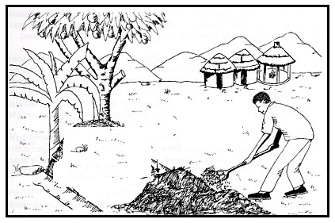
34. Name the type of manure made as shown in the diagram.
……………………………………………………………………………………………………........
35. Why is it important to add ash in the above type of manure during preparation?
……………………………………………………………………………………………………........
36. Give any way of preventing the diseases of the reproductive system.
……………………………………………………………………………………………………........
37. Name the method of harvesting trees that involves cutting off side branches of a tree only.
……………………………………………………………………………………………………........
38. What effect is solved by fixing electric wires loosely on poles during installation?
……………………………………………………………………………………………………........
39. How is the function of the skin similar to that of the kidneys?
……………………………………………………………………………………………………........
40. In which one way does recycling conserve the environment?
……………………………………………………………………………………………………........

SECTION B: 60 MARKS
41.(a) Give the meaning of the term germination.
……………………………………………………………………………………………………........
(b) Name any one type of germination.
……………………………………………………………………………………………………........
(c) Besides softening the testa, why else is water necessary during germination?
……………………………………………………………………………………………………........
(d) How is the process of germination useful to plants?
……………………………………………………………………………………………………........
42.(a) Mention any one example of the following types of chickens.
(i) Broilers…………………………………………………………………………………………
(ii) Layers …………………………………………………………………………………………
(b) Give any two ways a farmer can improve on the production of his poultry.
i) ………………………………………………………………………………………………………
ii) ………………………………………………………………………………………………………
43.(a) Give any one characteristic of essential drugs.
……………………………………………………………………………………………………........
(b) State any one way people misuse drugs.
……………………………………………………………………………………………………........
(c) Write any one danger caused by drug.
……………………………………………………………………………………………………........
(d) State any one way of keeping drugs out of reach of children at home.
……………………………………………………………………………………………………........
44. The diagram below is of an eye defect. Use it to answer questions that follow:
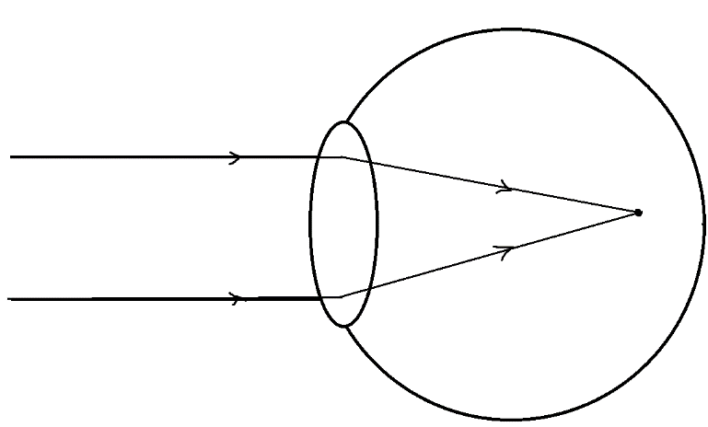
(a) Name the eye defect in the diagram above.
……………………………………………………………………………………………………........
(b) State any one cause of the eye defect named in (a) above.
……………………………………………………………………………………………………........
(c) How can such an eye defect be corrected?
……………………………………………………………………………………………………........
(d) Apart from the eye defect above, name any other eye defect.
……………………………………………………………………………………………………........
45.(a) Write any one example of a root tuber and stem tuber.
(i) Root tuber……………………………………………..………………………………………….
(ii) Stem tuber………………………………………………………………………………………..
(b) Give any one method used in the propagation of tuber crops.
……………………………………………………………………………………………………........
(c) Why is it recommended to heap soil around the stems of tubers during weeding?
……………………………………………………………………………………………………........
46. The diagram below is of a fish. Use it to answer questions.
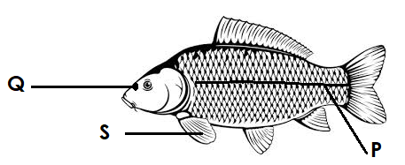
(a) Name the part marked Q and S.
(i)Q ………………………………………….. (ii)S ………………………………………………
(b) How is part marked P similar to the human ear?
……………………………………………………………………………………………………........
(c) State any one difference between a fish and a reptile.
……………………………………………………………………………………………………........
47. (a) Give the meaning of the following terms.
(i)Health survey.
……………………………………………………………………………………………………........
(ii)Demography
……………………………………………………………………………………………………........
(b) Why should a government carry out demography in the community?
……………………………………………………………………………………………………........
(c) Give any one way of collecting information during health surveys.
……………………………………………………………………………………………………........
48.(a) State the importance of the following tools to a dairy farmer.
(i)Strip cup
……………………………………………………………………………………………………........
(ii) Lactometer
……………………………………………………………………………………………………........
(b) How does boiling of milk keep it for a long time?
……………………………………………………………………………………………………........
(c) Give any one disadvantage of boiling as a method of preserving milk.
……………………………………………………………………………………………………........
49. The diagram below shows an iron and a glass rod that were dipped in hot water with pieces of Vaseline placed on each rod at the same time. Study it carefully and answer the questions that follow:
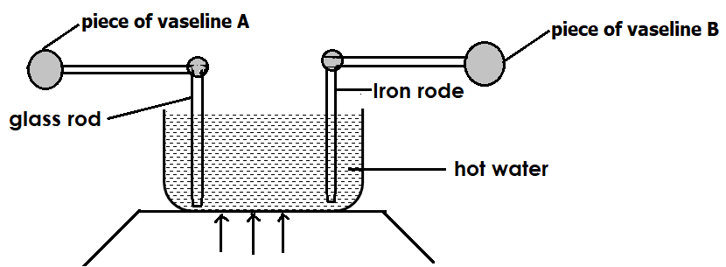

(a) Name the method of heat transfer that enables heat from hot water to reach the pieces of Vaseline.
……………………………………………………………………………………………………........
(b) Which pieces of Vaseline will melt and fall off first after sometime?
……………………………………………………………………………………………………........
(c) Give a reason to support your answer in (b) above.
……………………………………………………………………………………………………........
(d) Why does heat travel fastest in gases?
……………………………………………………………………………………………………........
50 (a) Mention any two examples of non-flowering plants that reproduce by means of seeds.
(i)……………………………………………………………………………………………………….
(ii)………………………………………………………………………………………………………
(b)How are the following plants propagated?
(i)white yam …………………………………………………………………………………………
(ii) beans ……………………………………………………………………………………………
51. (a)Identify the immunisable disease with the following effects to the victim
(i)Lameness and paralysis
……………………………………………………………………………………………………........
(ii) stiffness of body muscle
……………………………………………………………………………………………………........
(b)Write down two methods used to administer vaccines.
(i)……………………………………………………………………………………………….………
(ii)………………………………………………………………………………………………………
52. The diagram below shows a structure of two types of blood vessels. Use to answer questions that follow:
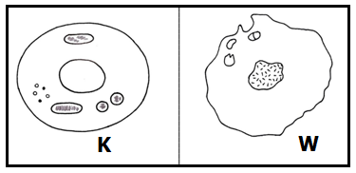
(a) Name the type of blood c represented by diagrams K and W.
(i)K ……………………………………………… (ii) W……………………………………
(b) Give an example of the type of blood vessel marked W.
……………………………………………………………………………………………………........
(c) How is circulation of blood important to the body?
……………………………………………………………………………………………………........
53. (a)Apart from pregnant women and weaning babies, mention other two vulnerable groups of people.
(i)………………………………………………………………………………………………………
(ii)………………………………………………………………………………………………………
(b) State any one way of caring for a pregnant women.
……………………………………………………………………………………………………........
(c) Why should weaning babies be given soft food?
……………………………………………………………………………………………………........
54 Study and complete the table below about the components of an electric circuit and their function.
Symbol of components of an electric circuit | function
__________________ | Produces electricity
 | _____________________________
_______________ | Breaks the circuit in case of too much flow of current
 | _________________________________

55. You are provided with a dry lump of soil, a transparent bucket and water. Describe
an experiment you would carry out to prove that soil has air. (4 marks)
……………………………………………………………………………………………………........
……………………………………………………………………………………………………........
……………………………………………………………………………………………………........
……………………………………………………………………………………………………........
……………………………………………………………………………………………………........
……………………………………………………………………………………………………........
……………………………………………………………………………………………………........
……………………………………………………………………………………………………........
……………………………………………………………………………………………………........
……………………………………………………………………………………………………........
……………………………………………………………………………………………………........
……………………………………………………………………………………………………........
……………………………………………………………………………………………………........
……………………………………………………………………………………………………........
……………………………………………………………………………………………………........
……………………………………………………………………………………………………........

END

